**Report on Minute-Level Main Fund Detection Alpha Performance**

**Introduction**

In financial markets, "main fund" refers to significant institutional investors such as hedge funds, mutual funds, and pension funds, collectively known as "smart money." Their trading activities, characterized by substantial net inflows and outflows, often precede major market movements. Understanding these transactions is crucial as they can significantly influence market dynamics.

**Main Fund, Institutional Transactions, and Smart Money**

Main funds are large-scale investors with significant market influence due to their trade volumes. Their strategies are based on extensive analysis and exclusive information, giving them a predictive edge. Institutional transactions by these entities create noticeable market trends driven by long-term strategies and fundamental analysis. "Smart money" refers to the capital controlled by these informed investors. Tracking smart money movements can provide critical insights for other market participants. Significant net inflow, indicating increased positions by main funds, often signals confidence in an asset's potential for growth.

**Importance of Main Fund Movements**

Main fund movements are key indicators for market participants. These movements, reflected in trading volume and price action, help infer the intentions of these funds, predicting future trends. Main funds influence market prices through large trades. Their trading patterns offer predictive insights. Institutional investors' access to superior information and tools provides valuable market direction insights. Main fund activities contribute to price discovery, clarifying asset value. Detecting main fund intentions aids informed investment decisions, such as recognizing accumulation signals indicating a bullish outlook.

**Methodology for Detecting Main Fund Intentions**

**Volume Threshold Method**

1. **Historical Volume Analysis:** For each trading day t, look back the previous k trading days with (t-k), t-(k-1),……,t-1,calculate the m percentile of the minute-by-minute volume series over these k days. In this study, k is set to 5 days and m is set to the 90th percentile.
2. **Comparing Current Day Volume:** Compare each minute's trading volume on day t with the calculated threshold. If the trading volume in a particular minute exceeds this threshold, the trade is influenced by main fund activity.
3. **Analyzing Main Fund Behavior:** After identifying the intraday main fund transactions, analyze the corresponding price and volume data to infer their trading intentions. This involves examining whether the main fund is accumulating or distributing the stock, which can then be used to construct predictive stock selection factors.

**Evaluation of Alpha Factor:**

**(the stocks are grouped evenly into 5 groups by their alpha values, with group 1 being the stocks with lowest 20 percent alpha value and group 5 with highest 20 percent alpha value. The performance of the strategy is shown by using group 1 to hedge against group 5.)**

**This analysis aims to evaluate the performance of a composite factor based on main fund trading prices and volumes. The evaluation considers multiple performance metrics, including overall PnL, long and short PnL, excess return, turnover ratio, cumulative IC, monotonicity of IC, and size exposure through 50 groups. Additionally, the composite factor is compared in terms of Sharpe ratio, mean IC value, and maximum drawdown to select the best strategy.**

**Performance Metrics**

1. **Overall PnL, Long, and Short PnL:**

Overall PnL: Measures the total profit and loss generated by the strategy.

Long PnL: Reflects profits and losses from long positions.

Short PnL: Reflects profits and losses from short positions.

**2.Excess Return:**

Excess Return: Calculated as the return of the strategy minus the benchmark return. It indicates the strategy's ability to outperform the market.(here the benchmark is set to be the average cumulative return of the entire Chinese A-Shares because this strategy select stocks from the entire market)

**3.Turnover Ratio:**

Turnover Ratio: Indicates how frequently the strategy trades. Higher turnover can lead to increased transaction costs, which may impact net returns.

Transaction Costs: Real-world trading incurs costs such as commissions and slippage. According to multiple sources, the typical transaction cost for institutional investors ranges from 0.1% to 0.5% per trade, depending on market conditions and trading volume.

**4.Cumulative IC (Information Coefficient):**

Cumulative IC: Measures the correlation between predicted and actual returns over time. A higher cumulative IC indicates a more stable and reliable strategy.

**5.Monotonicity of IC:**

Monotonicity of IC: Evaluates the consistency and accuracy of the strategy. A monotonically increasing IC suggests that the strategy consistently predicts returns correctly.

**6.Size Exposure:**

Size Exposure: Assessed through dividing the stocks into 50 groups based on market capitalization and analyzing the factor's performance across these groups. This helps identify any size bias in the strategy.

**7.Sharpe Ratio:**

Sharpe Ratio: Measures the risk-adjusted return of the strategy. It is calculated as the ratio of the strategy's excess return to its standard deviation. A higher Sharpe ratio indicates better risk-adjusted performance.

**8.Mean IC Value:**

Mean IC Value: The average Information Coefficient over time. A higher mean IC suggests better overall predictive power of the strategy.

**9.Maximum Drawdown:**

Maximum Drawdown: Measures the largest peak-to-trough decline in the strategy's value. It indicates the worst-case scenario for potential losses. Lower maximum drawdown values are preferred as they indicate better capital preservation during downturns.

**Main Fund Relative Average Price Factor**

**Introduction**

Main fund trading behavior often involves buying at low prices and selling at high prices. To evaluate this, we examine the relative price levels of main fund trades compared to the overall daily trading average.

1. **Daily Calculation:**

For each trading day, calculate the ratio of the volume-weighted average price (VWAP) of main fund trades to the VWAP of all minute-level trades for that day. Subtract 1 from this ratio to standardize the value.

**Daily Indicator=(VWAP of Main Fund Trades/VWAP of All Trades)−1**

1. **Monthly Calculation:**

At the end of each month, review the past 20 trading days and compute the average of the daily indicators. This average is then neutralized by market capitalization and industry (using CITIC first-level industry classification) to account for cross-sectional market variations, resulting in the main fund relative average price factor.

**Factor Logic**

High Factor Value: Indicates that the trading price of the main fund is relatively high compared to the daily average price. It is more likely that that the main fund might be selling off their holdings, indicating a bearish outlook for the stock.

Low Factor Value: Indicates that the trading price of the main fund is relatively low compared to the daily average price. It is more likely that the main fund might be accumulating positions at lower prices, indicating a bullish outlook for the stock.

By monitoring this factor, investors can gain insights into the trading strategies of main funds and make more informed investment decisions based on the inferred intentions of these significant market participants.

**Performance of Main Fund Alpha**

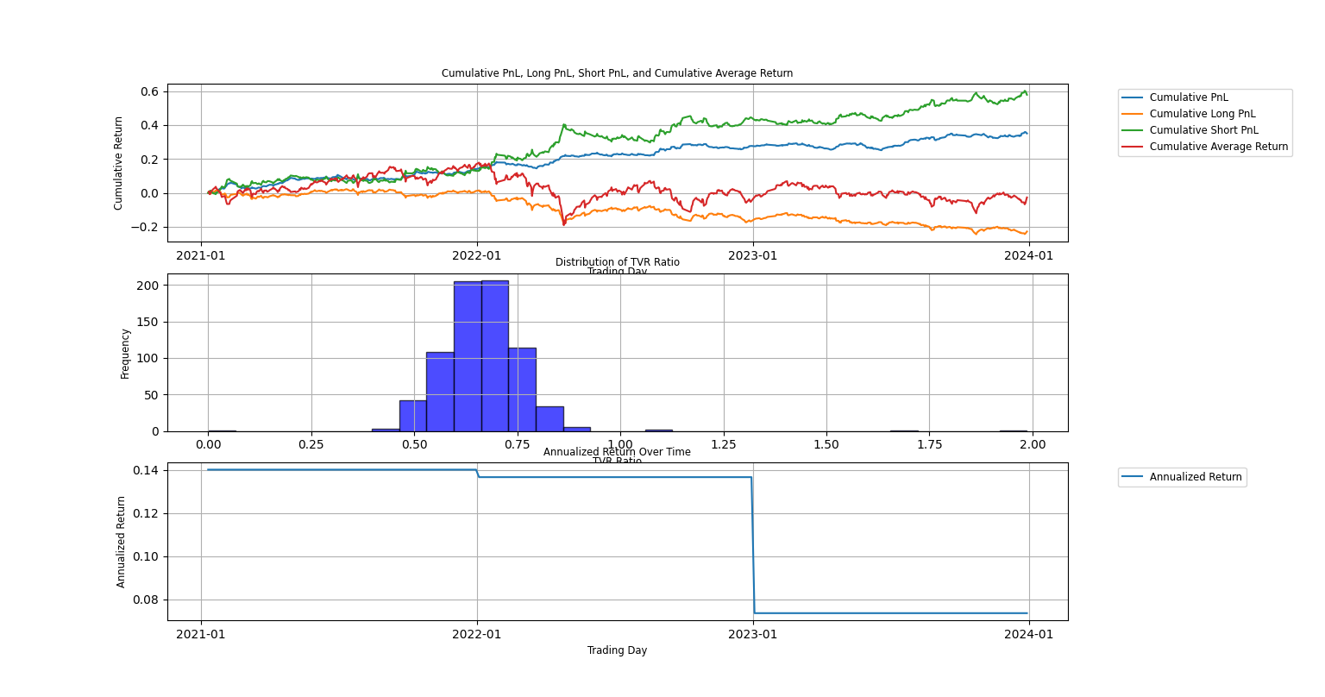

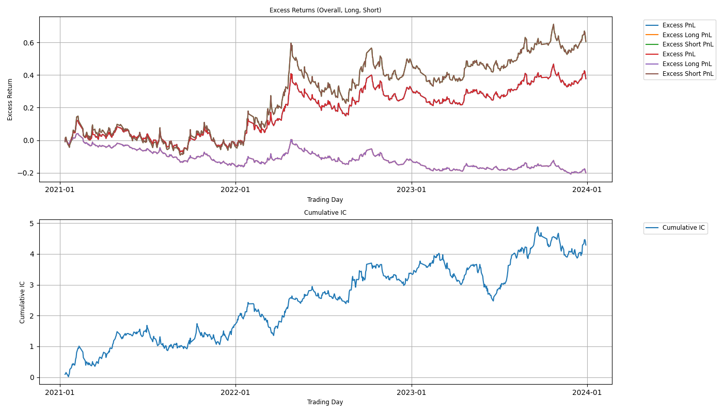

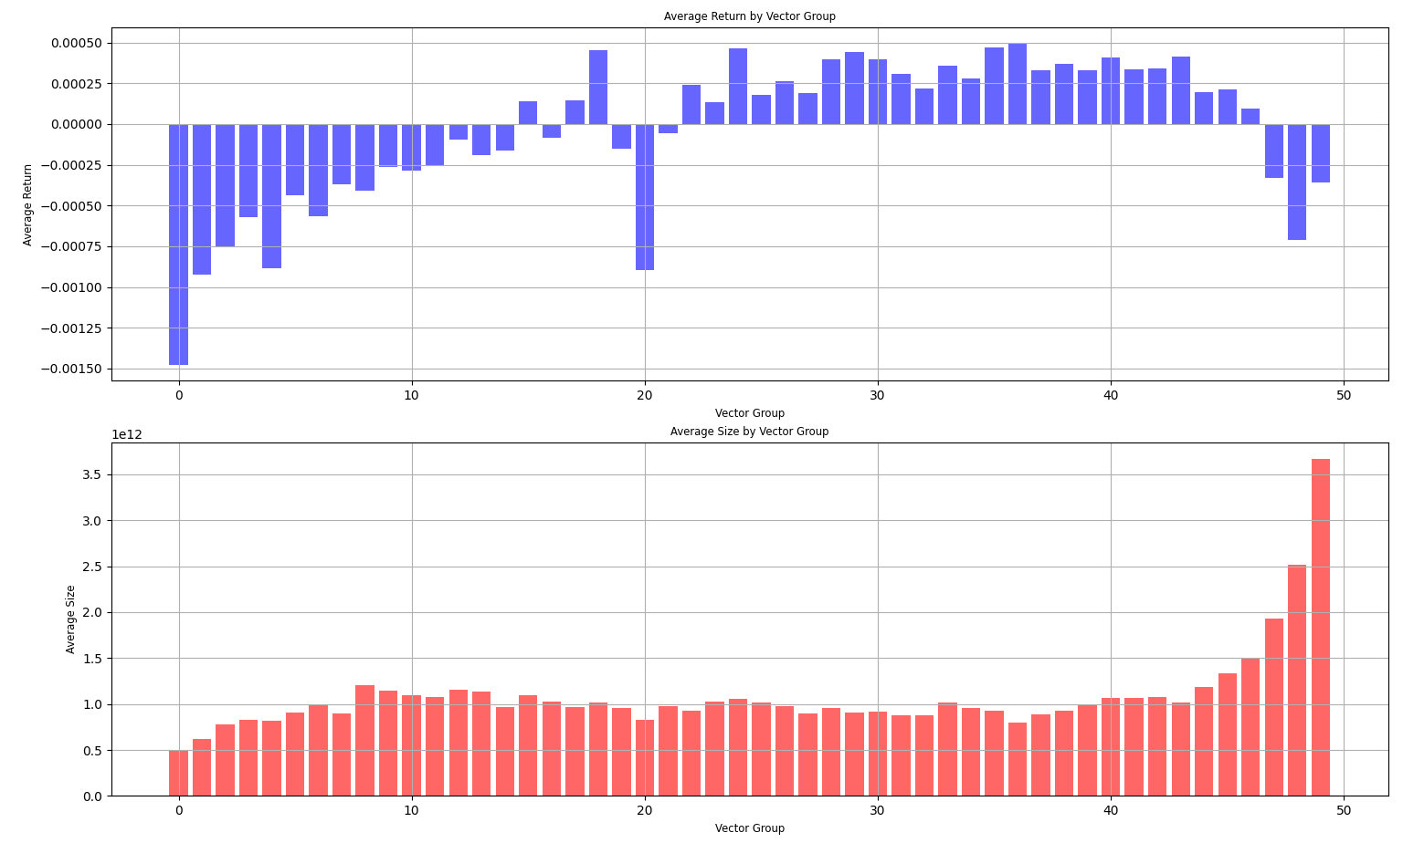

|  |  |
| --- | --- |
| Alpha | Main Fund Alpha |
| Sharpe ratio | 2.11 |
| Daily Mean IC | 0.006 |
| Maximum Retreat | 0.026 |
| Average turnover Ratio | 0.333 |

**Support and Resistance Volume Based on Full-Day Data**

**Introduction**

This method examines minute-level volume data throughout the trading day to define support and resistance volumes, constructing preliminary stock selection factors. By analyzing these volumes, we can infer the strength of price support or resistance levels, aiding in predicting future price movements.

**Methodology**

**1.Support Volume:**

For each trading day, calculate the average of all minute-level closing prices.

Select minutes where the closing price is less than this average price and sum their trading volumes to obtain the support volume.

**2.Resistance Volume:**

Similarly, select minutes where the closing price is greater than the average price and sum their trading volumes to obtain the resistance volume.

**3.Net Support Volume Factor:**

For each day, compute the factor as **(Support Volume−Resistance Volume)/Daily Circulating Shares**

**4.Moving Average and Size Industry Neutralization** At the end of each month, review the past 20 trading days, calculate the 20-day average of this factor. Neutralize this average for market capitalization and industry to obtain the net support volume factor.

**Factor Logic**

High Factor Value: Indicates strong support levels that are unlikely to be breached, suggesting a higher probability of future price increases.

Low Factor Value: Indicates strong resistance levels that may hinder price increases, suggesting a bearish outlook

**Performance of All-Data SupRes Alpha**

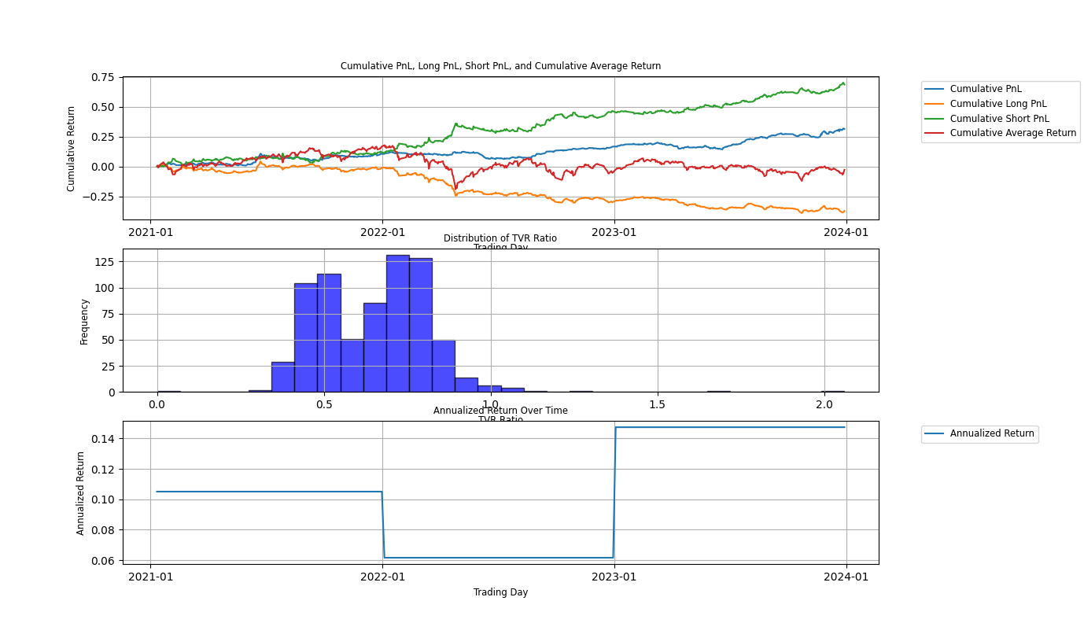.

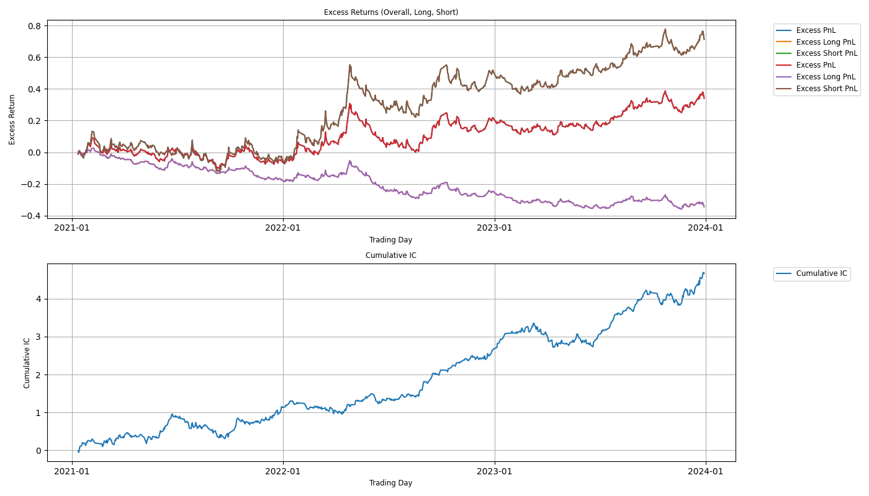

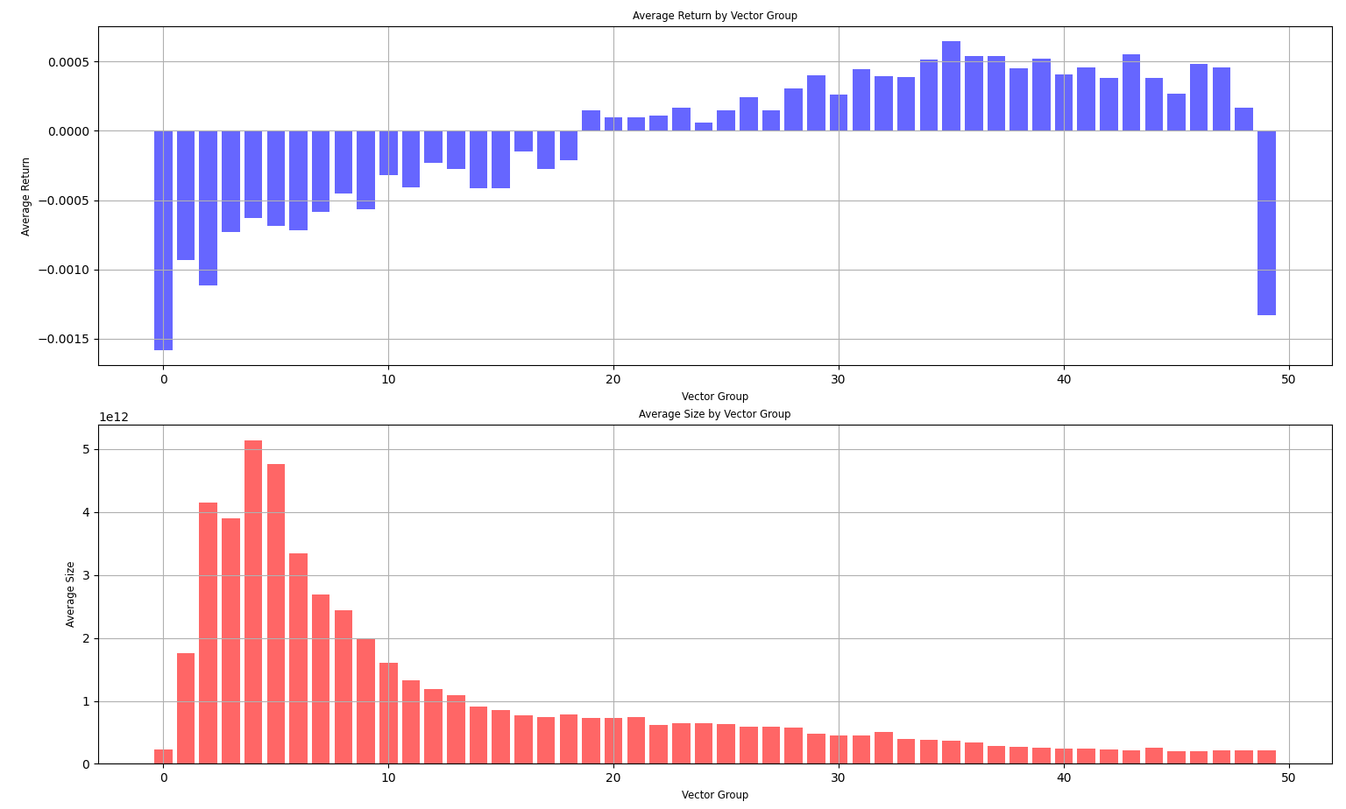

|  |  |
| --- | --- |
| Alpha | Full Day SupRes Alpha |
| Sharpe ratio | 2.160 |
| Daily Mean IC | 0.006 |
| Maximum Retreat | 0.029 |
| Average turnover Ratio | 0.651 |

**Support and Resistance Volume Based on of Main Funds**

**Introduction**

This method constructs the support and resistance volumes solely based on main funds transactions to construct a more robust stock selection factor. By analyzing these volumes, we aim to identify the trading behavior of significant institutional investors and predict future price movements.

**Methodology**

**1.Identifying Main Fund Activity:**

Each trading day, identify main fund activities by calculating the 90th percentile of the past 5 days' minute-level trading volumes.

Main fund activities are defined as those minutes where the trading volume exceeds this threshold.

**2.Support Volume of Main Funds:**

Calculate the average closing price of all main fund activity minutes.

Select minutes where the closing price is less than this average and sum their trading volumes to obtain the support volume of main funds.

**3.Resistance Volume of Main Funds:**

Similarly, select minutes where the closing price is greater than the average price and sum their trading volumes to obtain the resistance volume of main funds.

**4.Net Support Volume Factor:**

For each day, compute the factor as **(Support Volume of Main Funds−Resistance Volume of Main Funds)/Daily Circulating Shares**

**5.Moving Average and Size Industry Neutralization**

At the end of each month, review the past 20 trading days, calculate the 20-day average of this factor.

Neutralize this average for market capitalization and industry to obtain the net support volume factor of main funds.

**Factor Logic**

High Factor Value: Indicates strong support levels created by main funds that are unlikely to be breached, suggesting a higher probability of future price increases.

Low Factor Value: Indicates strong resistance levels created by main funds that may hinder price increases, suggesting a bearish outlook.

**Performance of Main Fund SupRes Alpha**

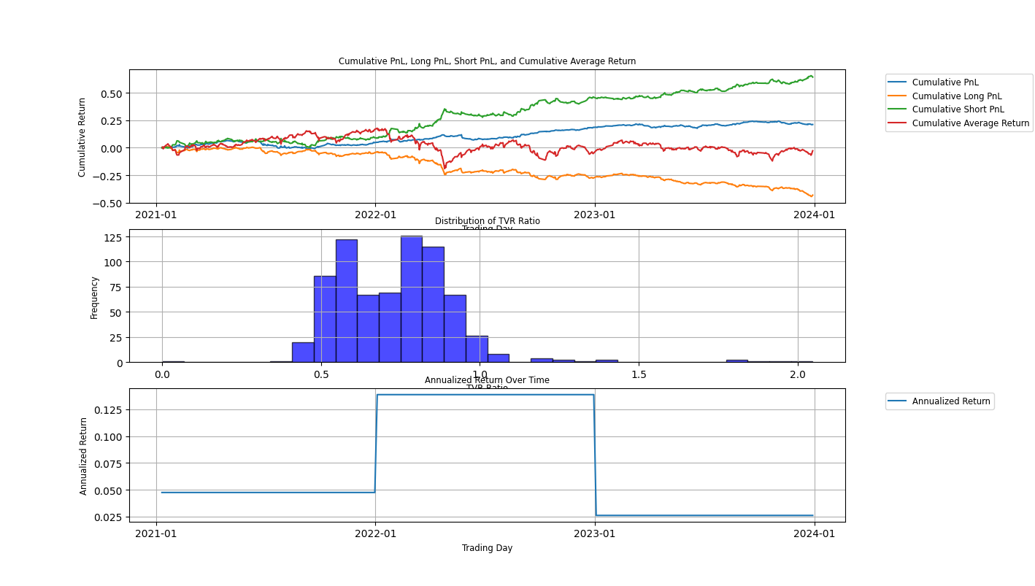

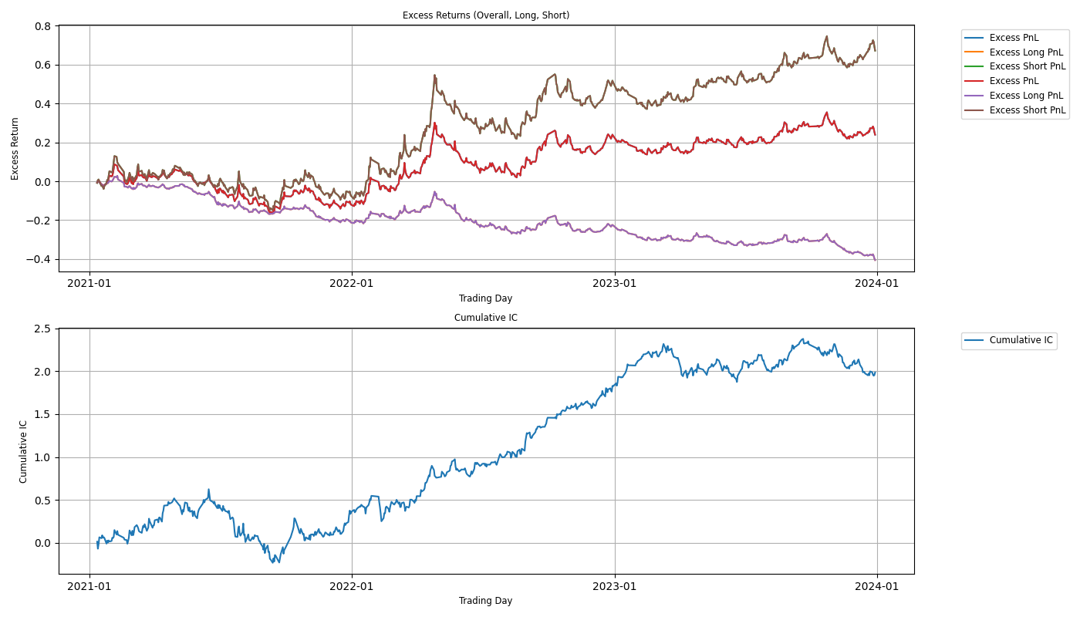

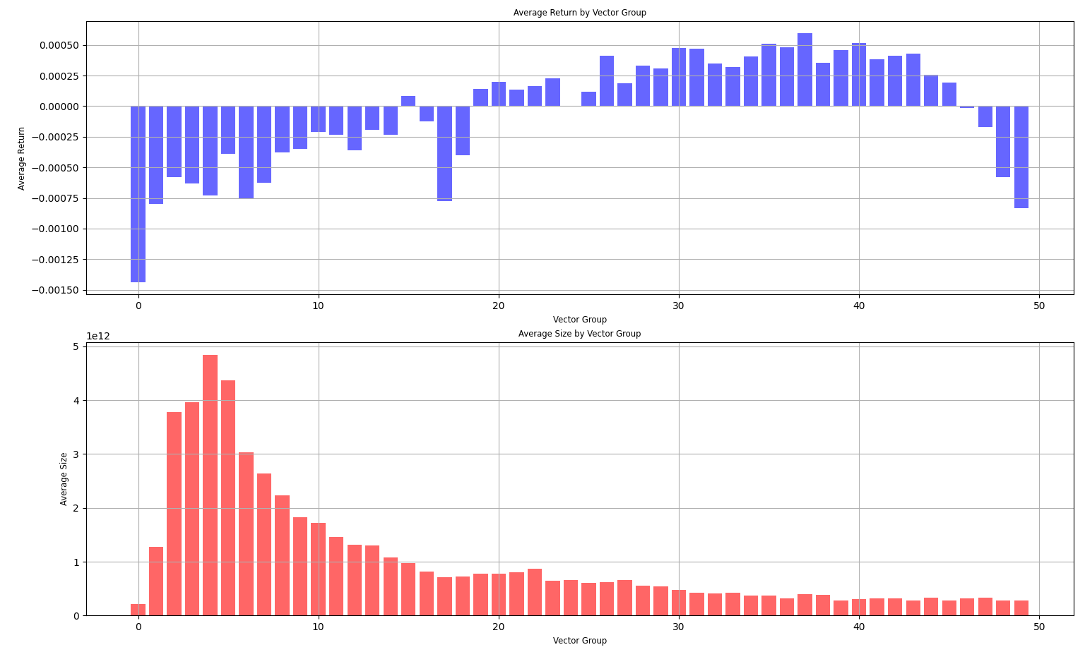

|  |  |
| --- | --- |
| Alpha | Main Fund SupRes Alpha |
| Sharpe ratio | 1.206 |
| Daily Mean IC | 0.002 |
| Maximum Retreat | 0.049 |
| Average turnover Ratio | 0.735 |

**Composite Factor Based on Main Fund Trading Price and Volume**

The composite factor is constructed by equally weighting factors derived from the main fund's trading price and volume. This composite factor aims to capture the overall trading behavior of main funds, providing a comprehensive indicator for stock selection.

The composite factor is calculated as **-1*zscore(main fund alpha)+zscore(full day volume alpha)**

**Performance of Composite Alpha**

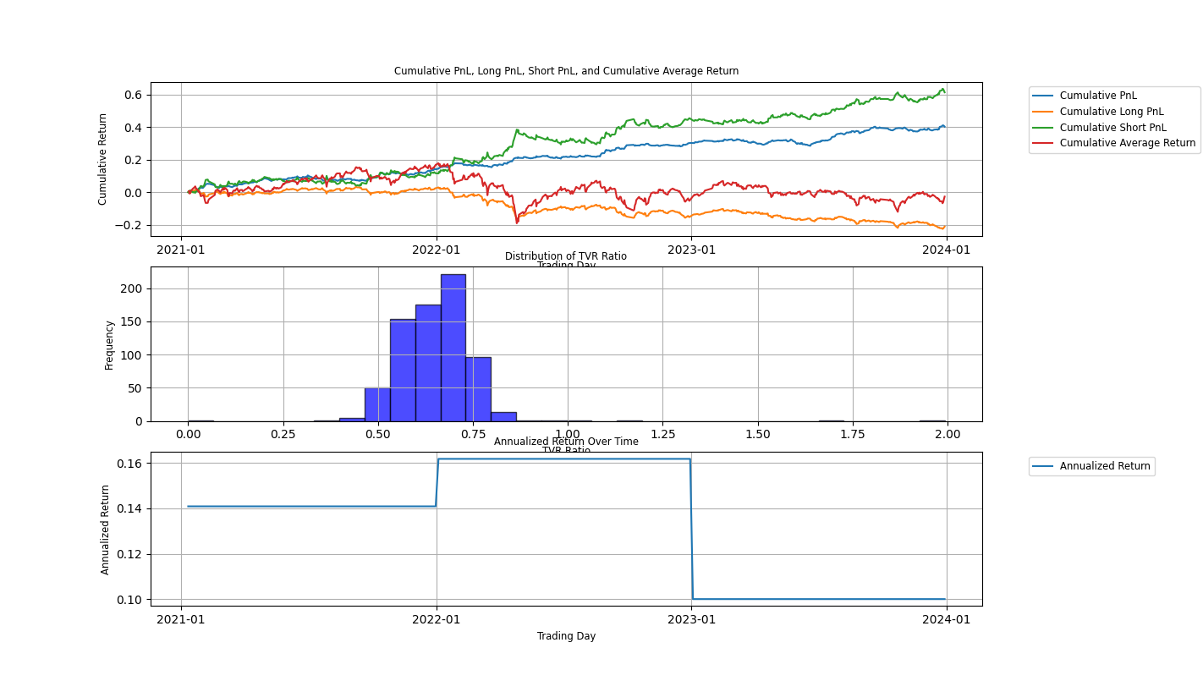

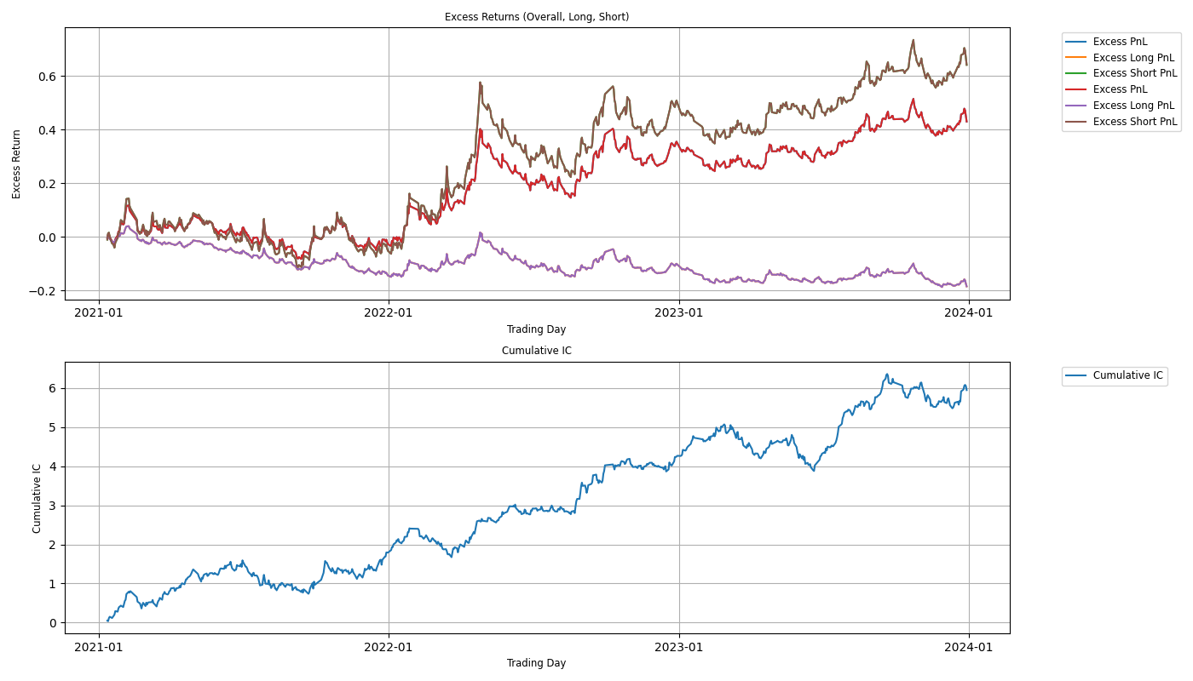

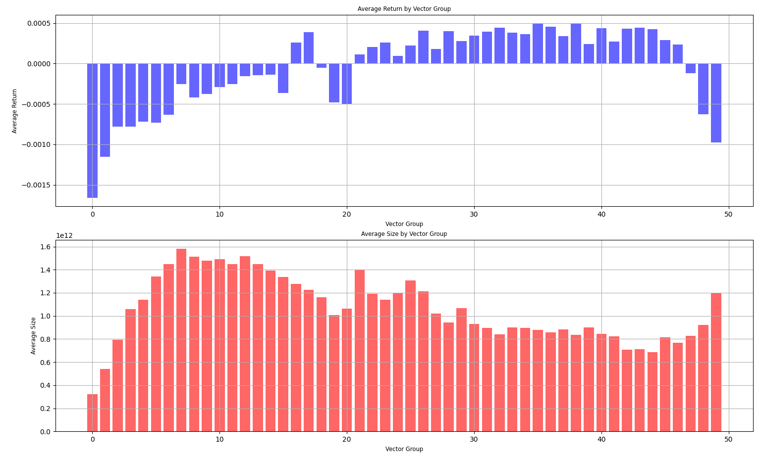

|  |  |
| --- | --- |
| Alpha | Composite Alpha |
| Sharpe ratio | 2.105 |
| Daily Mean IC | 0.006 |
| Maximum Retreat | 0.027 |
| Average turnover Ratio | 0.664 |

**Conclusion based on Performance Metrics:**

Based on the performance metrics, the main fund relative average price alpha is the best single alpha strategy. This conclusion is supported by the following key findings:

**Highest Sharpe Ratio (2.11):** The main fund relative price alpha demonstrates superior risk-adjusted returns, indicating that it effectively balances return and volatility.

**Relatively Low Turnover Ratio (0.33):** A lower turnover ratio suggests reduced transaction costs, making the strategy more cost-efficient in real trading scenarios.

**Strong Explanatory Power and Stability:** This alpha exhibits a high Information Coefficient (IC) mean value and good monotonicity, reflecting its consistent predictive power and reliability over time.

**Low Maximum Drawdown:** The strategy maintains a lower maximum drawdown, indicating better capital preservation and reduced risk of significant losses.

**Size Exposure and Risk Reduction**

However, the grouping analysis shows that even after size neutralization, any single alpha still has exposure to high market capital: Relative Price Alpha has high exposure to large-cap stocks on the right tail, while Support and Resistance Alpha shows high exposure to large-cap stocks on the left tail.

**Weight Assignment Logic and Risk Reduction**

Based on the logic of our weight assignment, stocks with high market capitalization tend to be assigned more weight than those with lower capitalization. However, combining the two strategies (relative price alpha and support/resistance alpha) results in a more even distribution of size across groups. This even distribution reduces the size exposure and, consequently, the unsystematic risk.

**Unsystematic Risk**

Unsystematic risk (also known as idiosyncratic risk) refers to the risk associated with individual assets. It can be reduced through diversification. When combining two alphas that have different size exposures, the composite alpha can balance out the individual biases, leading to a reduction in unsystematic risk.

Formula for Portfolio Variance

The variance of a portfolio , given by

Where is the weight assigned to i-th asset,

is the standard deviation of the i-th asset,

and is the correlation between i-th asset and j-th asset.

By ensuring that the weights ​ are more evenly distributed, we can reduce the first term (which represents the contribution of individual asset risks). Moreover, the second term (which represents the co-movement of asset pairs) can also be minimized if the assets are less correlated.

**Composite Alpha**

The composite of the relative price alpha and the support/resistance alpha results in a more balanced size distribution. This balance reduces exposure to large-cap stocks and diminishes unsystematic risk, leading to a more stable and reliable investment strategy. This approach not only harnesses the strengths of individual alphas but also mitigates their weaknesses, resulting in a robust composite strategy.

Moreover, the composite alpha offers a higher Sharpe ratio (2.16), lower maximum drawdown, and stronger explanatory power (as shown by the monotonicity and cumulative sum of IC). It also shows less exposure to the size factor, reducing systematic risk and emerging as the most robust factor. This comprehensive approach ensures that the strategy is not only effective but also sustainable in different market conditions, providing investors with a reliable tool for portfolio management.